|  |  |  |  |
| --- | --- | --- | --- |
| 1 | This is the main page. User can click on the Info button to view the Info page to understand how to play to the game , the user can click the Play button to play the game. When the user hover over the Info or Play button it will change text colour from black to blue and the Apple watch will rotate. | 2 | This is the Info page for the game. User can view the instruction to understand how to play the game and after reading all the instructions the user can click on the back button to go to the main page. When the user hover over the Back button it will change text colour from black to blue and the Apple watch will rotate. |
|  |  |  |  |

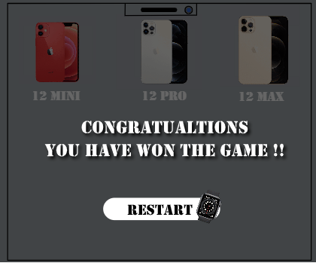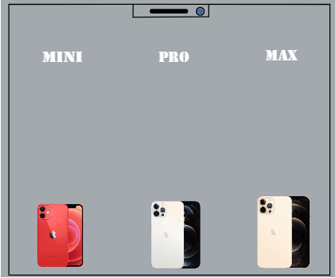 3 4

This is the win page. After matching all 3 I phone with the correct text, it will bring you to the win page and user can press the Restart Button to replay the game. When the user hover over the Restart button it will change text colour from black to blue and the Apple watch will rotate.

This is the game page. After clicking on the Play button, it will bring you to the game page. User will drag the I phone to play the game. To win the game, the user will need to match all 3 I phone with the correct text and it will go to the win page.